SIMATS ENGINEERING (SAVEETHA SCHOOL OF ENGINEERING)
Department of Computer Science and Engineering
CO1 ASSESSMENT TOOL 1 – Case Study Analysis
Course Code: | CSA10 / CSA1004 | Course Title: | Software Engineering
CO Assessed: | CO1 | Assessment: | Assessment Tool 1 – Case Study Analysis
Weightage: | 20% | Total Marks: | 25
CO1 Statement: | Apply advanced methodologies and agile project management techniques to manage software projects effectively
Student Name: | K Sreelatha | Reg. No.: | 192425248
Date: | 10/10/2026 | Duration: | 60 minutes

Code of Conduct
I _K Sreelatha(192425248)_ (Name / Reg No) certify that this submission is my original work and that I have adhered to the guidelines specified for this assessment. I understand that any violation of academic integrity rules will result in disciplinary action.
Signature of the Student: ____Sree K_____
Annexure A – Case Study Analysis
Instructions to Students:
Each student will be allotted one problem statement. Analyze the assigned problem systematically by following the steps given below. Your report should demonstrate your understanding of software engineering concepts and your ability to design an appropriate software solution.
Based on your allotted problem statement, prepare a report by answering the following questions:
- Understand the Problem Statement
  - Explain the problem in your own words.
  - Identify the objectives of the proposed system.
  - State the scope of the problem.
- Identify Key Stakeholders and Challenges
  - Identify all the stakeholders involved in the system.
  - Explain the roles and responsibilities of each stakeholder.
  - Discuss the major challenges and issues faced by the stakeholders.
- Analyze the Current Approach
  - Describe the existing system or current process.
  - Identify its strengths and limitations.
  - Analyze the problems or gaps that need to be addressed.
- Propose a Suitable Solution Using Software Engineering Principles
  - Design a software-based solution for the given problem.
  - Describe the major functional modules of the proposed system.
  - Identify the functional and non-functional requirements.
  - Explain how software engineering principles such as modularity, scalability, maintainability, reliability, usability, and security are incorporated into your solution.
- Justify the Chosen Methodology/Framework
  - Select an appropriate Software Development Life Cycle (SDLC) model or software development framework (e.g., Agile, Scrum, Waterfall, Spiral, DevOps).
  - Justify why the selected methodology/framework is suitable for the proposed system.
  - Explain how it supports successful project development and maintenance.
- Discuss Expected Outcomes and Limitations
  - Describe the expected benefits of the proposed solution.
  - Explain how the solution addresses the identified challenges.
  - Discuss potential risks, implementation challenges, and limitations.
  - Suggest possible future enhancements.

INTELLIGENT PUBLIC TRANSPORT MONITORING SYSTEM
1. Introduction
Public transportation is an important part of daily life. People depend on buses to travel to colleges, offices, hospitals, and other places. However, passengers often face problems such as unpredictable bus arrival times, overcrowding, route inefficiencies, and a lack of real-time information.
The Intelligent Public Transport Monitoring System is a software-based solution designed to monitor buses and provide useful information to passengers and transport administrators. It uses vehicle location data to display bus positions, estimate arrival times, provide route information, and monitor passenger occupancy.
2. Problem Statement
Traditional public transport systems may not provide accurate real-time information about bus locations, arrival times, and passenger occupancy. This causes passengers to wait unnecessarily and makes it difficult for transport administrators to monitor services efficiently.
Therefore, an Intelligent Public Transport Monitoring System is proposed to improve bus tracking, passenger information, route management, and operational monitoring.
3. Objectives
The main objectives are:
- To track public transport vehicles.
- To provide real-time vehicle locations.
- To estimate bus arrival times.
- To monitor passenger occupancy.
- To manage bus routes and schedules.
- To detect service delays.
- To provide operational analytics to transport administrators.
4. Scope
The system focuses on bus tracking, passenger information, route and schedule management, occupancy monitoring, and delay detection.
Passengers can view bus locations, routes, estimated arrival times, and occupancy information. Transport administrators can monitor bus operations and analyze service performance.
The system can be extended in the future to support multiple transport services and advanced traffic prediction.
5. Key Stakeholders
Stakeholders are the people or organizations involved in or affected by a software system.
1. Passengers
Passengers use the system to check bus locations, estimated arrival times, routes, and occupancy information.
Challenges: Uncertain waiting times, overcrowded buses, and limited travel information.
2. Bus Drivers
Drivers operate buses and follow assigned routes and schedules.
Challenges: Traffic congestion, unexpected delays, and schedule changes.
3. Transport Administrators
Administrators monitor bus operations, manage routes and schedules, and analyze service performance.
Challenges: Difficulty monitoring multiple buses, identifying delays, and improving route efficiency.
4. Transport Authorities
Transport authorities supervise public transport services and make operational decisions.
Challenges: Maintaining reliable services, allocating resources, and improving passenger satisfaction.
5. System Administrator
The system administrator maintains user access, system configuration, and data security.
Challenges: Preventing unauthorized access, maintaining system availability, and resolving technical issues.
6. Major Challenges
The main challenges addressed by the proposed system are:
- Unpredictable arrival times: Passengers may not know when a bus will arrive.
- Overcrowding: Passengers may not know the occupancy level before boarding.
- Service delays: Administrators may have difficulty identifying delayed buses.
- Route inefficiencies: Poor monitoring may make it difficult to identify routes that need improvement.
- Limited information: Passengers may lack access to current bus locations and schedules.
- Data accuracy: Incorrect location or occupancy information can reduce the reliability of the system.
7. Existing System
In a traditional public transport system, passengers may depend on printed schedules, bus stops, announcements, or manual enquiries to obtain travel information.
Transport administrators may use schedules, driver reports, and manual monitoring to supervise bus operations.
These methods can provide basic information, but they may not provide continuous updates about vehicle locations, occupancy, and delays.
8. Strengths of the Existing System
- Simple to operate.
- Printed schedules can be used without an internet connection.
- Requires fewer advanced technical resources.
- Familiar to passengers and transport staff.
9. Limitations of the Existing System
- Does not always provide real-time bus locations.
- Estimated arrival times may be unavailable or inaccurate.
- Passengers may not know whether a bus is overcrowded.
- Identifying delays can require manual effort.
- Operational data may not be available in one centralized system.
- Analyzing route performance can be difficult.
10. Identified Gaps
The main gaps are the lack of integrated real-time tracking, arrival-time estimation, occupancy monitoring, automatic delay detection, and centralized operational analytics.
The proposed system addresses these gaps by combining vehicle monitoring and passenger information with administrative tools.
11. Proposed System
The Intelligent Public Transport Monitoring System is designed to collect bus location and operational information and make it available to passengers and transport administrators.
A GPS-enabled device or equivalent location-data source can provide vehicle coordinates. The system processes the data to display bus locations and estimate arrival times. Occupancy information can be obtained through manual entry, passenger-counting devices, or suitable sensors.
The system can compare actual vehicle progress with scheduled timings to identify potential service delays.

12. Major Functional Modules
Module 1: Real-Time Bus Tracking
Collects vehicle location data and displays the current bus position.
Module 2: Arrival-Time Estimation
Estimates when a bus will reach a selected stop using location, route, and timing information.
Module 3: Route and Schedule Management
Allows authorized administrators to add or update bus routes and schedules.
Module 4: Passenger Occupancy Monitoring
Displays the reported or detected passenger occupancy level, such as low, medium, or high.
Module 5: Delay Detection
Identifies potential delays by comparing actual progress with scheduled timings.
Module 6: Operational Analytics
Provides administrators with information about delays, route performance, and vehicle operations.
13. Functional Requirements
Functional requirements describe what the system must do.
- The system must display bus locations.
- The system must estimate bus arrival times.
- The system must display route and schedule information.
- The system must provide passenger occupancy information.
- The system must identify potential service delays.
- The system must allow authorized administrators to manage routes and schedules.
- The system must generate operational reports.
14. Non-Functional Requirements
Non-functional requirements describe how well the system should operate.
- Performance: Location and arrival information should update promptly.
- Reliability: The system should provide dependable information when data sources are available.
- Usability: The interface should be simple for passengers and administrators.
- Security: Only authorized users should manage administrative information.
- Scalability: The system should support additional buses, routes, and users.
- Maintainability: The software should be easy to test, update, and repair.
15. Software Engineering Principles
- Modularity: Separate modules handle tracking, arrival estimation, occupancy, and analytics.
- Scalability: The design should allow more buses and routes to be added.
- Maintainability: Individual modules can be updated without redesigning the entire system.
- Reliability: The system should validate incoming data and handle missing location updates.
- Usability: Clear screens help passengers find travel information quickly.
- Security: Authentication and access control protect administrative functions.

16. Selected Methodology: Agile Scrum
Agile is a software development approach that supports incremental development and feedback. Scrum is an Agile framework in which work is organized into manageable tasks and short development cycles called sprints.
Scrum is suitable for this project because the system contains several independent modules, including bus tracking, arrival estimation, occupancy monitoring, and operational analytics.
The team can develop and test these modules incrementally, review the results, and improve the system based on feedback.
17. How Scrum Is Applied
Product Backlog: A prioritized list of project requirements, such as bus tracking, route management, and delay detection.
Sprint Planning: The team selects tasks to complete during a sprint.
Sprint: A fixed period during which the team develops and tests selected features.
Daily Scrum: A short meeting to discuss progress, plans, and obstacles.
Sprint Review: The team demonstrates completed features and collects feedback.
Sprint Retrospective: The team identifies improvements for the next sprint.
Jira can be used to organize the backlog, assign tasks, manage sprint activities, and track work status.
18. Expected Outcomes
- Better access to bus location information.
- More informed passenger travel decisions.
- Improved visibility of bus arrival estimates.
- Better awareness of passenger occupancy.
- Faster identification of service delays.
- Improved route and schedule management.
- Data-supported operational decisions.
19. Risks and Limitations
- GPS signals may be unavailable or inaccurate.
- Network failures may delay location updates.
- Arrival-time estimates may be affected by traffic conditions.
- Occupancy information may be inaccurate if sensors or manual updates fail.
- Implementation requires suitable hardware, software, and maintenance.
- Passenger and vehicle data must be protected against unauthorized access.

20. Future Enhancements
- Artificial intelligence-based arrival-time prediction.
- Automatic passenger counting using sensors.
- Mobile application notifications about delays.
- Traffic-aware route recommendations.
- Integration with multiple public transport services.
- Historical data analysis for better service planning.
21. Conclusion
The Intelligent Public Transport Monitoring System aims to improve public transportation by providing bus location information, arrival-time estimates, occupancy details, route management, and operational analytics.
Using modular software design and Agile Scrum project management can support incremental development, testing, and maintenance. Jira helps the development team organize requirements, prioritize tasks, manage sprints, and monitor progress.
The proposed system can improve passenger information and help transport administrators make better operational decisions, provided that reliable data sources and suitable technical infrastructure are available.
Output:
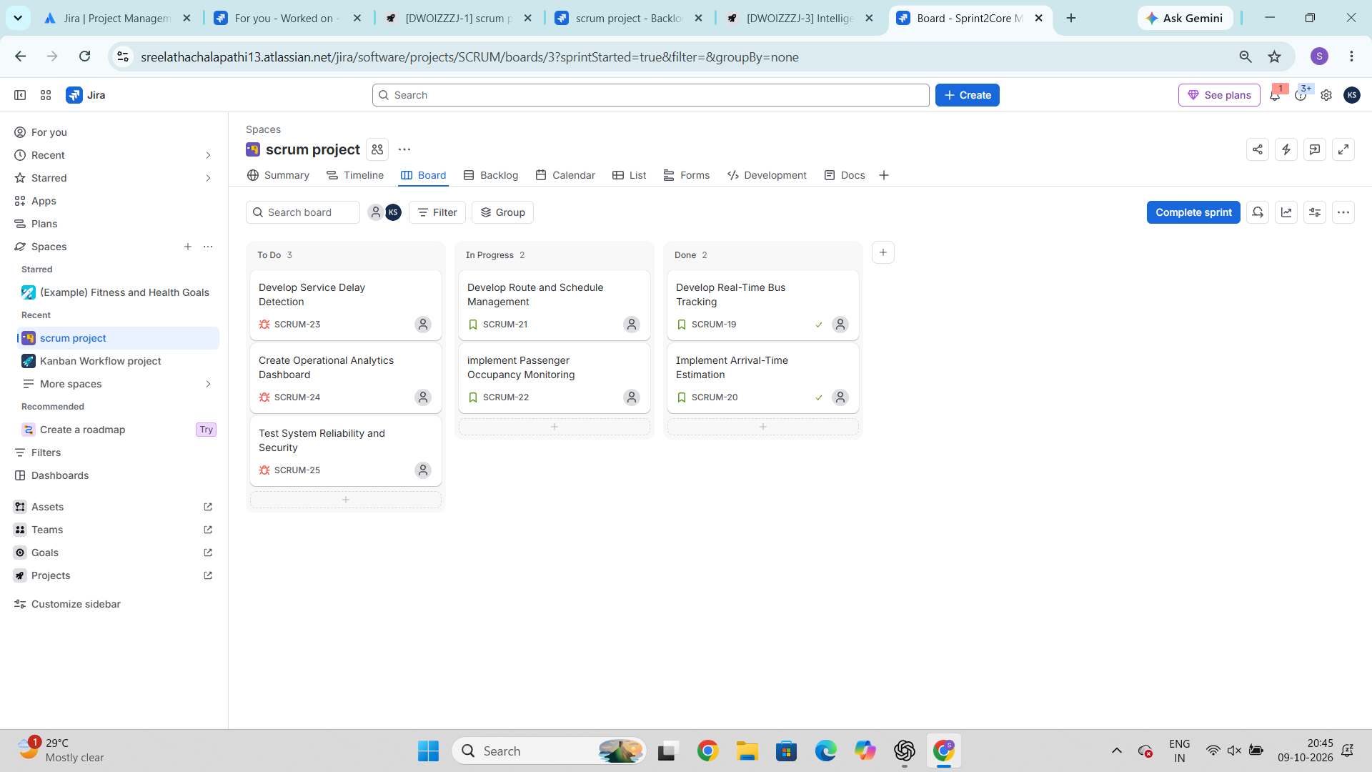

Rubrics for Calculation
Criteria | Excellent (5 Marks) | Good (3 Marks) | Satisfactory (2 Marks) | Needs Improvement (1 Mark)
Problem Understanding (30%) | Clearly explains the problem, objectives, and scope with complete understanding. | Explains the problem with minor omissions. | Basic understanding with limited explanation. | Poor understanding; objectives and scope are unclear or missing.
Stakeholder & Challenge Analysis (25%) | Identifies all stakeholders, their roles, and challenges with clear analysis. | Identifies most stakeholders and challenges with adequate analysis. | Identifies only a few stakeholders or challenges. | Stakeholders and system analysis are incomplete or inaccurate.
Current System Analysis (20%) | Thoroughly analyzes the existing system, strengths, weaknesses, and identifies all gaps. | Good analysis with most strengths and weaknesses identified. | Limited analysis with partial identification of issues. | Proposed solution is unclear or inappropriate; requirements are largely missing.
Proposed Software Solution & Software Engineering Principles (15%) | Proposes an innovative, feasible solution applying appropriate software engineering principles (modularity, scalability, maintainability, security, etc.). | Suitable solution with good application of software engineering principles. | Basic solution with limited application of software engineering principles. | Methodology is inappropriate, poorly justified, or not discussed.
Methodology/ Framework Justification (10%) | Selects the most suitable SDLC/model/framework and provides strong technical justification. | Suitable methodology selected with adequate justification. | Methodology selected but justification is weak. | Outcomes, limitations, or future enhancements are missing; report lacks organization and clarity.

Criteria | Mark
Problem Understanding (30%) | /5
Stakeholder & Challenge Analysis (25%) | /5
Current System Analysis (20%) | /5
Proposed Software Solution & Software Engineering Principles (15%) | /5
Methodology/ Framework Justification (10%) | /5
TOTAL | /25

